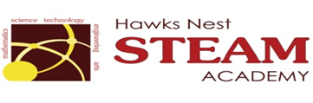School Counseling Program Newsletter
Shandrai Silva, School Counselor | November 2017
Counselor Message  Happy November! As we enter the season of thanksgiving, I am grateful for the many great things happening at Hawks Nest STEAM Academy! In October alone, there were several field trips, the Cardboard Challenge, Book Fair, and Fall Festival. Through our school counseling program, students and staff participated in Red Ribbon Week and Unity Day. Congratulations to our Red Ribbon Week Door Decorating Contest winners: Ms. Patz/Mrs. Branton & Ms. Blake for Kindergarten – 2nd grades and Ms. Minnich for grades 3-5. In classroom guidance, students engaged in lessons about Bullying Prevention, Fairness, Making Healthy Choices, Social- Emotional Learning, and Digital Citizenship.  November’s going to be another awesome month at Hawks Nest where we aspire to have a learning environment that inspires success and a lifetime of learning!  How to see the school counselor  Classroom guidance classes, based on grade level specials schedule, are either weekly or bi-weekly. Small group counseling and individual counseling by self -referral, parent referral, teacher referral, administrator referral or counselor initiated.  Contact School Counselor at 704-866-8467or sosilva@gaston.k12.nc.us. | Home of the Hawks  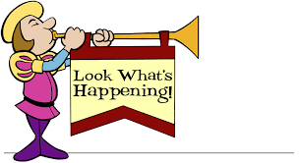  World Kindness Day  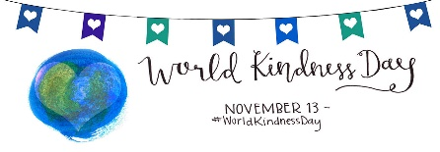  In recogntion of Workd Kindness Day on November 13th, Hawks Nest STEAM Academy is collecting canned goods to donate to local helping organizations.  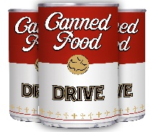  November 6 – 13, 2017  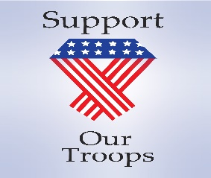  GCS Miltiary Support Day  November 9, 2017  Wear Red, White or Blue | Promoting Character Education  “We’re Soaring with Good Character”  ______________________________  The character trait of the month is Respect. Respect is taking turns, sharing, and listening to what others have to say; treating others respectfully.  ______________________________________________  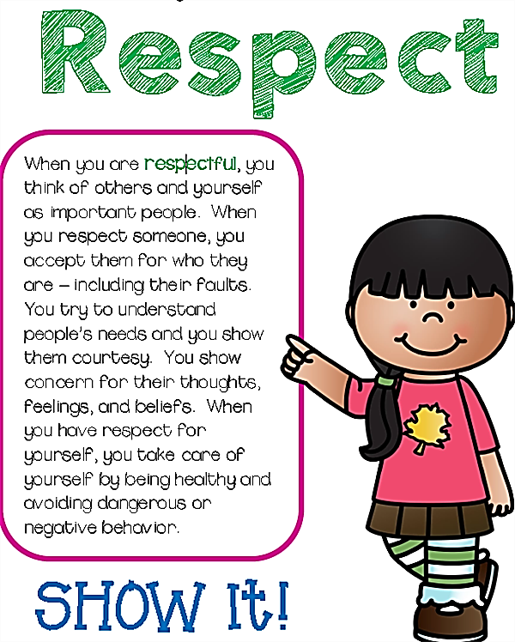  https://www.redclayschools.com/Page/1159  Bucket Filler’s are Respectful  Ask your student about the Bucket Filler’s Pledge.  